**DAILY ONLINE ACTIVITIES SUMMARY**

|  |  |  |  |  |  |  |  |
| --- | --- | --- | --- | --- | --- | --- | --- |
| **Date:** | **12-06-20** | | | | **Name:** | **SAHANA C** | |
| **Sem & Sec** | **VI B** | | | | **USN:** | **4AL17CS116** | |
| **Online Test Summary** | | | | | | | |
| **Subject** | | **Pap assisgnment test** | | | | | |
| **Max. Marks** | | **30** | | **Score** | | **28** | |
| **Certification Course Summary** | | | | | | | |
| **Course** | Programming Essentials in Python | | | | | | |
| **Coding Challenges**  **A magic square of order n is an arrangement of n^2 numbers, usually distinct integers, in a square, such that the n numbers in all rows, all columns, and both diagonals sum to the same constant. A magic square contains the integers from 1 to n^2.**  **Python program to print the pattern.** | | | | | | | |
| **Certificate Provider** | | | **Cisco -python institution** | **Duration** | | | **No limit** |
| **Status:on going** | | | | | | | |
| **Uploaded the report in Github** | | | | **Yes** | | | |
| **If yes Repository name** | | | | **https://github.com/sahanasanu/Daliy-status** | | | |
| **Uploaded the report in slack** | | | | **Yes** | | | |

**IA MARKS DETAILS:**

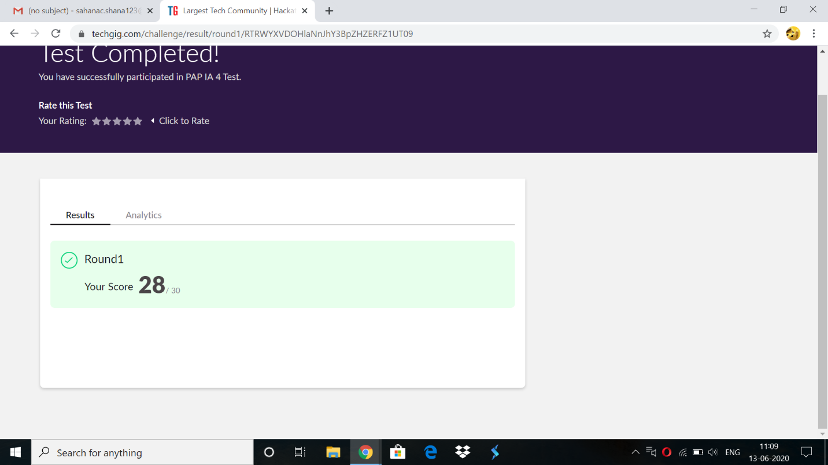

**Online Certification Details:**

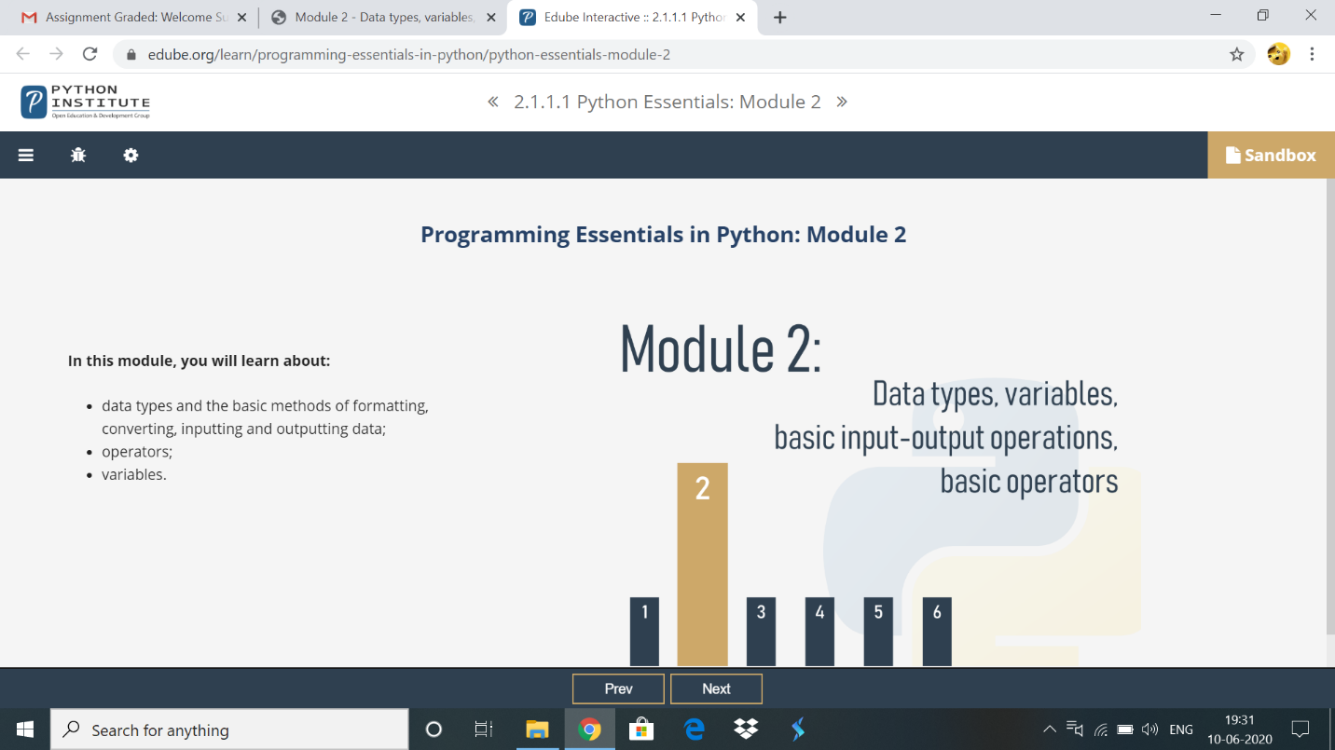Topics covered:

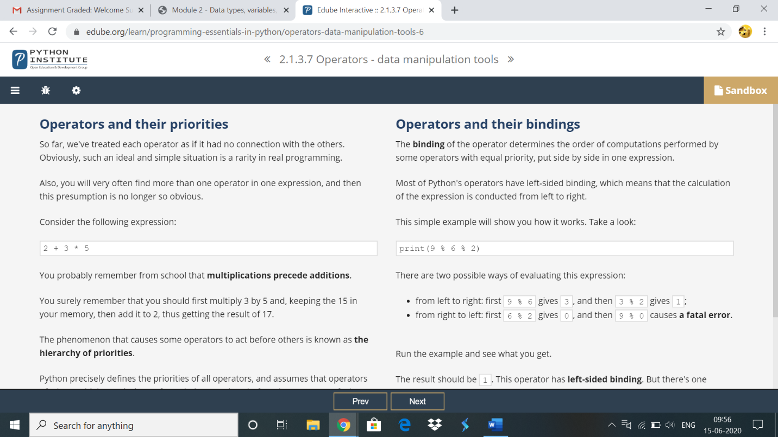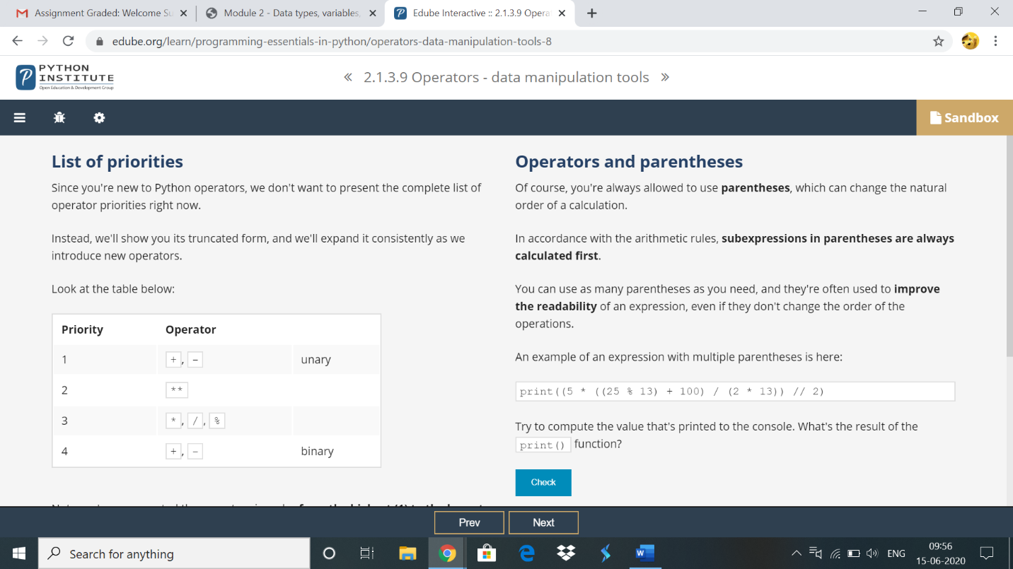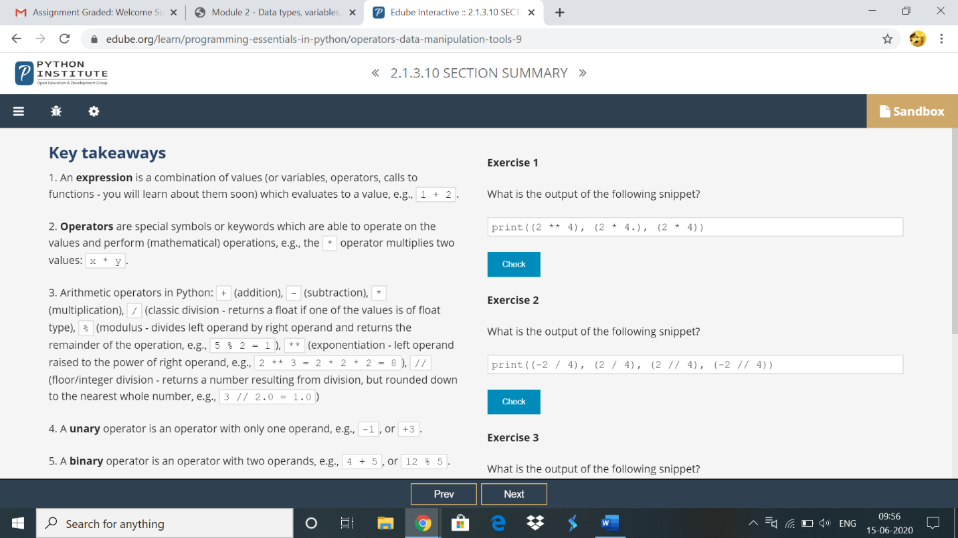

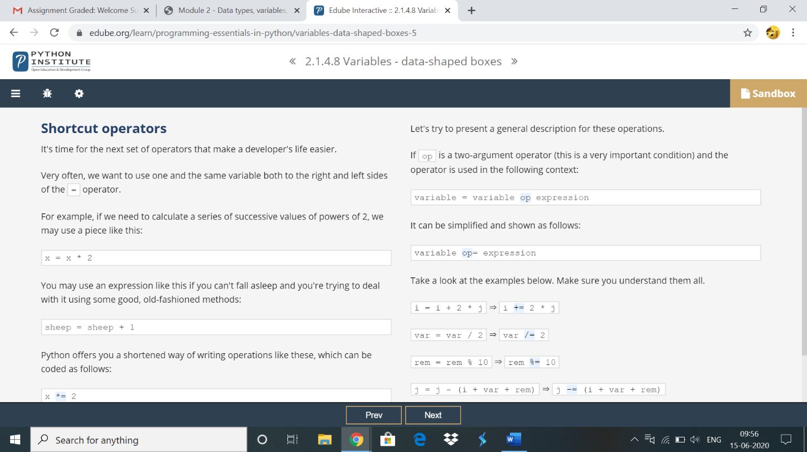

**Online coding:**

**1) A magic square of order n is an arrangement of n^2 numbers, usually distinct integers, in a square, such that the n numbers in all rows, all columns, and both diagonals sum to the same constant. A magic square contains the integers from 1 to n^2.**

def gSqua(n):

magic_square = [[0 for x in range(n)] for y in range(n)]

i = n / 2

j = n - 1

num = 1

while num <= (n * n):

if i == -1 and j == n:

j = n - 2

i = 0

else:

if j == n:

j = 0

if i < 0:

i = n - 1

if magic_square[int(i)][int(j)]:

j = j - 2

i = i + 1

continue

else:

magic_square[int(i)][int(j)] = num

num = num + 1

j = j + 1

i = i - 1

print("Magic Squre For n =", n)

print('Sum Of Each Row Or Column Or Diagonal: ', n * (n * n + 1) / 2, "\n")

for i in range(0, n):

for j in range(0, n):

print('%2d ' % (magic_square[i][j]), end='')

if j == n - 1:

print()

n = int(input("Enter The Number For Magic Square: "))

gSqua(n)

**Output:**

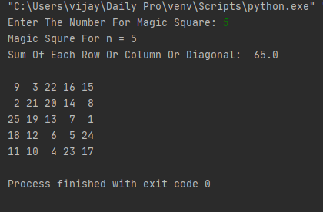

**Python program to print the pattern.**

n = int(input("Enter The N Value: "))

for i in range(1, n + 1):

print(" " * (n - i), "*" * i, end="\n")

for i in range(n - 1, 0, -1):

print(" " * (n - i), "*" * i, end="\n")

**Output:**

